THE GOOD GRIEF PROJECT

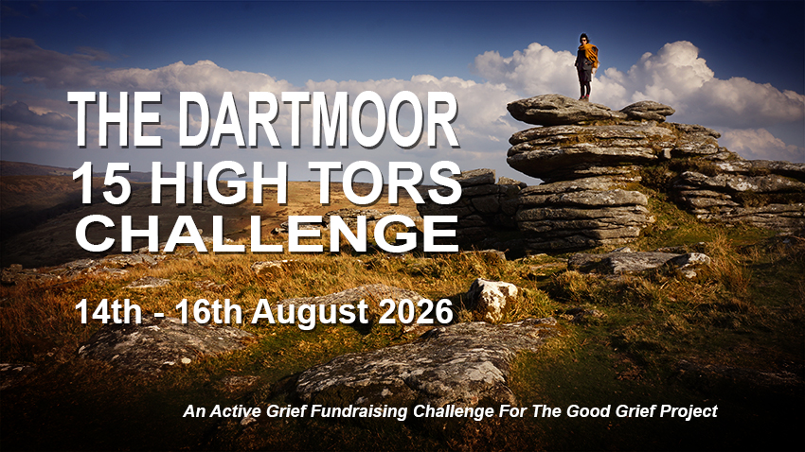

THE DARTMOOR 15 HIGH TORS CHALLENGE
14th-16th AUGUST 2026
Application FORM

We are pleased to invite you to join us for THE GOOD GRIEF 15 HIGH TORS FUNDRAISING CHALLENGE on DARTMOOR - 14TH-16TH AUGUST 2026. The challenge is open exclusively to bereaved parents and siblings and their immediate friends and family. Our aim is to trek 20 miles and climb 15 tors in under 10 hours. The cost to join is just £100 per person (to include bunkhouse accommodation, one evening meal and professional support throughout the weekend). As part of the challenge you are asked to raise at least £1000 to assist low-income families attend our ACTIVE GRIEF WEEKEND retreats. Your joining fee will be refunded once this figure is reached. Please complete this form and return to us as soon as you can. Do not send any money now. We will be in touch once we have reviewed your form.

ABOUT YOU:
The Dartmoor 15 HighTors Challenge is open exclusively to bereaved parents and siblings and their immediate friends and family. (minimum age 18)

Your Name:
Address (inc Postcode):

Email:
Phone number: | Your age:
Your occupation (optional)

ABOUT YOUR IDENTITY:
We are committed to an inclusivity that reflects the diverse nature of society. Ethnic origin is not about nationality, place of birth or citizenship. Similarly sexual orientation and gender identity is not defined by a fixed set of parameters. It’s about the group to which you perceive yourself to belong.

Do you consider yourself belonging to an ethnic minority group?
Yes: please qualify | No | Prefer not to say:

Do you identify as LGBTQ+
Yes: please qualify | No | Prefer not to say:

ABOUT YOUR CHILD/ren or sibling – who are you honouring with your challenge?

Name/s of your child/ren or sibling

Date/s of death: | Age/s at death:
Cause/s of Death

Your relation to them:

ABOUT THE CHALLENGE:
This is a weekend event arriving at Bernards Acre bunkhouse on Friday 14th August, completing the challenge on Saturday and departing on Sunday 16th August. The challenge itself is exciting and rewarding but physically demanding and a good base of fitness is necessary to navigate rough and uneven ground, with significant climbs and descents.
To help determine whether the 15 HIGH TORS CHALLENGE is suitable for you — and to ensure everyone can take part safely and confidently — it’s important that we understand your current experience and fitness level. Please answer the following questions as honestly as possible. There are no “right” or “wrong” answers — this is simply about making sure the challenge is the right fit for you.

Previous Experience. Have you completed a similar long-distance walking or endurance challenge before? If yes, please tell us when and what it was (e.g. distance, terrain, how long it took).

Current Walking Fitness. On a normal walk of 2–3 miles on standard paths or pavements, what is your average walking speed – miles per hour?
If you’re unsure, please consider completing a simple test: Time yourself by walking 2–3 miles at your normal steady pace and share the result:
Distance in miles ….. | Time ….
Average speed (miles per hour) ….
This will give us a helpful starting point for understanding your current fitness level.

Medical or Physical Considerations. Please list any medical conditions, injuries, or physical concerns that could affect your ability to complete the challenge (eg: asthma, joint issues, previous injuries, etc.)? This information will be treated sensitively and helps us ensure your safety and wellbeing.
Our aim is to make sure everyone who takes part is well-matched to the demands of the challenge and is set up for a positive and successful experience.
ABOUT FUNDRAISING:
As part of the challenge, you are required to raise funds in aid of The Good Grief Projects ACTIVE GRIEF programme of weekend retreats and on-line training sessions. We will be guiding you with full instructions on how to create your own online fundraising page linked to THE GOOD GRIEF PROJECTS JustGiving account.

Please indicate approximately how much you think you can raise | £

REMEMBER – we will refund your joining fee as soon as you have raised £1000

BOOKING :
Similar to our ACTIVE GRIEF WEEKENDs the Dartmoor 15 High Tors Challenge is a residential weekend based at Bernards Acre near Oakhampton. We arrive at 4 pm on Friday and leave on Sunday. We welcome applications from family teams up to a maximum of four. Please complete a separate form for each team member.
Please indicate how many places you require:

PAYMENT : We do not require payment at this moment. Once we have your completed form we will ask for a deposit of £100 to secure your place/s.

DO NOT SEND ANY MONEY NOW …
WE WILL BE IN TOUCH 0NCE WE HAVE REVIEWED YOUR FORM

WHAT TO DO NOW : If you have completed the form digitally – please SAVE AS adding your name like this – 15TORS2026(your name).docx and return as an attachment to the following email – info@thegoodgriefproject.co.uk

If you have printed and completed the form in long hand – please either scan and return as above or mail to: The Dartmoor 15 High Tors Challenge
THE GOOD GRIEF PROJECT
3 Rowes Farm Barns, Stoke Gabriel, Totnes
DEVON, TQ9 6RT
Cancellations:
If you want to cancel your place, please let us know at least one month before the start date and we will refund your payment. After this date, we are sorry, but our charity is unable to offer any refunds.

If for any reason we have to cancel the event, we will endeavour to inform you in good time. We will also give you a full refund and pay all reasonable and necessary additional expenditure (ie travel expenses) incurred by you as a result of the cancellation.

For more about THE GOOD GRIEF PROJECT please click here

