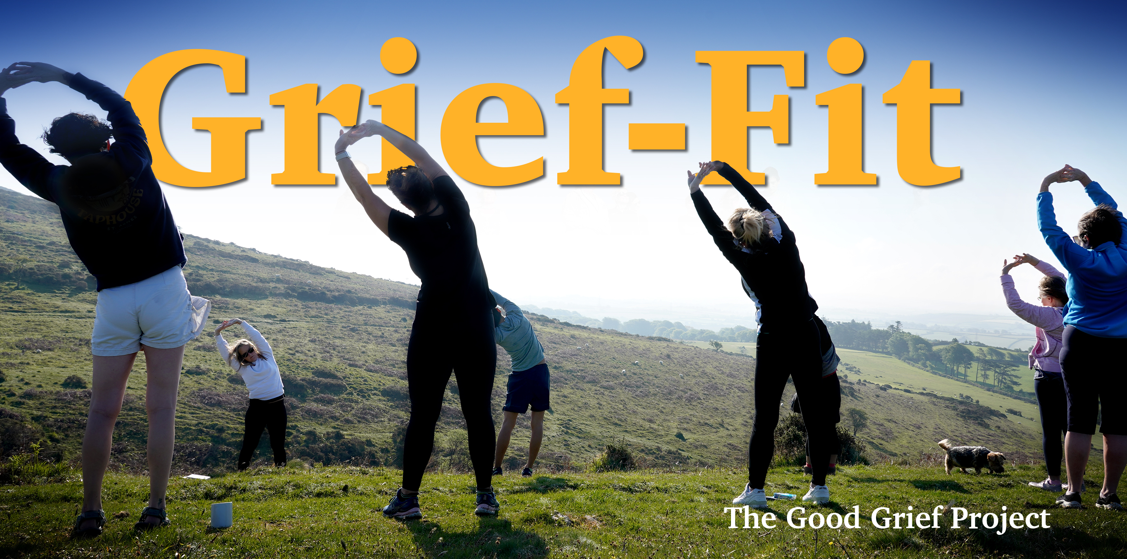

Grief – Fit
APPLICATION FORM
A remote fitness programme to promote physical and mental well-being and to
help you navigate your grief within a supportive community.

A nine week fitness programme open to any bereaved parent or sibling

Train at times of your own choosing

A fitness app for your own personal training programme

Monthly 1-2-1 Coaching calls – Monthly video meets

WhatsApp group for peer-to-peer support

On going fitness advice and guidance
including nutrition and weight management support

Sliding scale fees: £75 - £150
ABOUT YOU :
Your Name:
Address (inc Postcode):

Email:
Phone number: | Your age:
Your occupation (optional)

ABOUT YOUR CHILD/ren or sibling:

Name/s of your child/ren or sibling.

Birth date/s | Date/s of death: | Age/s at death:
Cause/s of Death

Your relation to them:

Is this/are these your only child/ren or siblings?

PREFERRED Grief-Fit PROGRAMME : please tick

Each programme last for nine weeks from the start date as follows:
2ND JUNE 2025
13th OCTOBER 2025

ABOUT YOUR FITNESS:
There is no need to be especially fit to take part in Grief-Fit. All activities are tailored to meet the wide range of ability and fitness levels
Please give us a rough indication of your fitness (mark with X one box only)
1 – Very low (example - I can become out of breath from walking / climbing stairs)
2 – Below average
3 – Moderate (example - I can withstand running or other cardio vascular exercise for more than 10 – 20 minutes)
4 – Higher than average
5 – Very high (example - I complete fitness based activity regularly and at a high intensity)

Please tell us how much exercise you currently do (mark with X one box only)
1 – 0 to 20 minutes per week
2 – 20 minutes to 1 hour per week
3 – 1 hour to 3 hours per week
4 – 3 hours – 5 hours per week
5 – 5 hours or more per week

Please list the types of exercise you currently do.
ABOUT YOUR HEALTH:
Have you ever been told by your doctor or health professional that you should not take part in physical exercise …. YES/NO
Do you have any previous or current injuries or medical conditions…. YES/NO
If YES to either of these please tell us about them below:
ABOUT YOUR ETHNICITY:
We are committed to an inclusivity that reflects the diverse nature of society. Ethnic origin is not about nationality, place of birth or citizenship. It is about the group to which you perceive you belong. Please tick the appropriate box

Asian or Asian British
Indian  Pakistani  Bangladeshi  Chinese  Prefer not to say 
Any other Asian background, please write in:

Black, African, Caribbean or Black British
African  Caribbean Any other Black, African or Caribbean background:
White and Black Caribbean White and Black African  White and Asian  Prefer not to say  Any other Mixed or Multiple ethnic background:

White
English Welsh  Scottish Northern Irish  Irish  British  Gypsy or Irish Traveller  Prefer not to say  Any other White background, please write in:

Other ethnic group
Arab Prefer not to say  Any other ethnic group:
BOOKING :

The full cost of the Grief-Fit nine week programme is £300 but THE GOOD GRIEF PROJECT wants to make it affordable for all. Please choose the price which is within your means.

£75 | £150 | Other £

WHAT TO DO NOW : If you have completed this form digitally – please SAVE AS adding your name like this – GRIEFFIT 25(your name).docx and return as an attachment to the following email – joe@thegoodgriefproject.co.uk

If you have printed and completed the form in long hand – please either scan and return as above or mail to: Grief-Fit
THE GOOD GRIEF PROJECT
3 Rowes Farm Barns,
Stoke Gabriel, Totnes TQ9 6RT

WHAT HAPPENS NEXT : SEND NO MONEY NOW. Once we have your completed form we will schedule an initial phone call with you to discuss the programme further and answer any questions you may have. We can then take payment and confirm your place on your chosen cohort.

For more about THE GOOD GRIEF PROJECT please click here

