THE GOOD GRIEF PROJECT

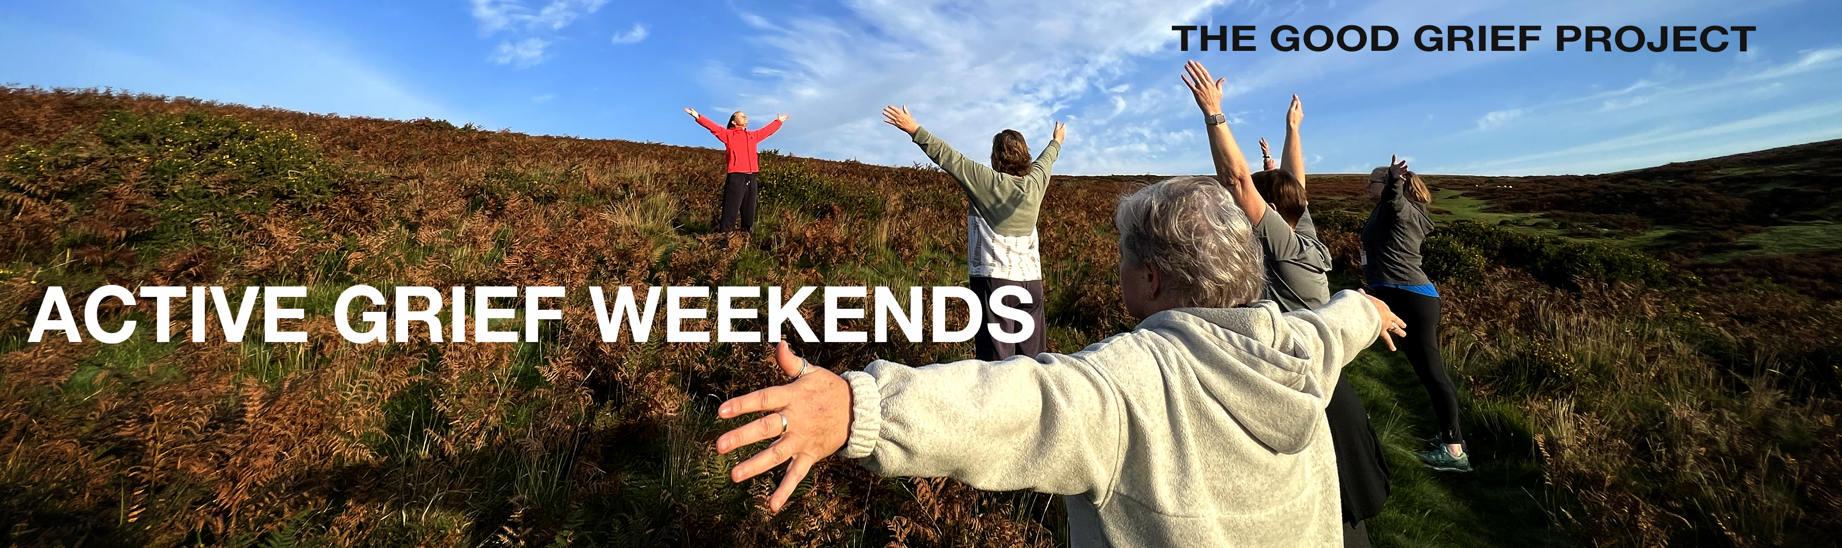

ACTIVE GRIEF WEEKEND retreats
Weekend retreats designed especially for and by bereaved parents and siblings

REGISTRATION FORM

9TH – 11TH MAY 2025 & 19th – 21st SEPTEMBER 2025
BLACKADON FARM on Dartmoor
We are pleased to invite you to join us for one of our ACTIVE GRIEF WEEKENDS at Blackadon Farm on Dartmoor, 9th – 11th May or 19th – 21st September 2025. Prices start from £250 per person (double occupancy) and include accommodation, full board, attendance to all sessions and more. Below you will be asked to state how much you can afford and whether you would like to apply for a bursary or sponsored place. Please complete this form and return to us with your payment. If you are applying for a bursary we will be in touch.

be INSPIRED: be CREATIVE: get PHYSICAL
join us for an ACTIVE GRIEF WEEKEND

REGISTRATION FORM

YOUR PREFERRED WEEKEND: please tick
9th-11th May 2025
19th – 21st Sept 2025

ABOUT YOU :
Your Name:
Address (inc Postcode):

Email:
Phone number: | Your age:
Your occupation (optional)

ABOUT YOUR ETHNICITY:
We are committed to an inclusivity that reflects the diverse nature of society. Ethnic origin is not about nationality, place of birth or citizenship. It is about the group to which you perceive you belong. Please tick the appropriate box

Asian or Asian British
Indian  Pakistani  Bangladeshi  Chinese  Prefer not to say 
Any other Asian background, please write in:

Black, African, Caribbean or Black British
African  Caribbean  Prefer not to say 
Any other Black, African or Caribbean background:

Mixed or Multiple ethnic groups
White and Black Caribbean  White and Black African  White and Asian  Prefer not to say  Any other Mixed or Multiple ethnic background:

White
English  Welsh  Scottish  Northern Irish  Irish 
British  Gypsy or Irish Traveller  Prefer not to say 
Any other White background, please write in:

Other ethnic group
Arab  Prefer not to say  Any other ethnic group:
ABOUT YOUR CHILD/ren or sibling:

Name/s of your child/ren or sibling

Date/s of death: | Age/s at death:
Cause/s of Death

Your relation to them:

Is this/are these your only child/ren or siblings?

We will be using these details to complete your identity tag as follows:

ACTIVE GRIEF WEEKEND
(Blackadon Farm September 2024)

YOUR NAME
Remembering
YOUR CHILDS/SIBLINGS NAME

THE GOOD GRIEF PROJECT

ABOUT THE WEEKEND :

The weekend is about encouraging an active as well as creative approach to grief. We want you to be inspired to find new ways of expressing your grief. There will be three 2 hour workshops for you to take part in – photography, creative writing and physical activity. All these sessions will include elements of mindfulness. There is no requirement for any previous experience in any of these disciplines.

Please tell us which activities you are most looking forward to? (please mark with X 5 = a lot , 1 = not at all)

Photography | 5 | 4 | 3 | 2 | 1
Active physical | 5 | 4 | 3 | 2 | 1
Creative Writing | 5 | 4 | 3 | 2 | 1
Mindfulness | 5 | 4 | 3 | 2 | 1

Do you have any particular skills or interests that you feel are relevant to attending the ACTIVE GRIEF WEEKEND?

How do you think you will benefit from attending the ACTIVE GRIEF WEEKEND ?

MORE ABOUT THE WEEKEND:
For the PHOTOGRAPHY WORKSHOP:
Please let us know which type of camera you will be using (mark any with X):

MOBILE PHONE: | COMPACT: | Digital SLR:

For the PHYSICAL ACTIVITY WORKSHOP:
Please offer a rough indication of your fitness levels (mark with X one box only)
1 – Very low (example - I can become out of breath from walking / climbing stairs)
2 – Below average
3 – Moderate (example - I can withstand running or other cardio vascular exercise for more than 10 – 20 minutes)
4 – Higher than average
5 – Very high (example - I complete fitness based activity regularly and at a high intensity)
Please offer a rough indication of how much exercise you currently do (mark with X one box only)
1 – 0 to 20 minutes per week
2 – 20 minutes to 1 hour per week
3 – 1 hour to 3 hours per week
4 – 3 hours – 5 hours per week
5 – 5 hours or more per week
Please list the types of exercise you currently do.

BOOKING :

The ACTIVE GRIEF WEEKEND is a residential weekend – arriving at 4 pm on Friday leaving on Sunday after lunch. The weekend is full board and all meals are included.
The venue at Blackadon Farm offer flexibility of twins and double beds. The fee for the weekend is £250 per person for double occupancy or £300 per person for single occupancy.
Please indicate how many places you require:
Twin/Double (£250 per person)
Single (£300 per person)

Can you afford the full cost of the weekend? | YES | NO
How much can you afford? | £
Would you like to apply for a bursary? | YES | NO
If YES please tell us why

The reason I/we would like to apply for a bursary to attend the ACTIVE GRIEF WEEKEND is because …

We will be contacting you about this.

Do you have any special dietary requirements?
Do you have any mobility requirements?

Our welcome packs will include a list of all attendees – are you happy to have your email address included? Please select. | YES | NO

PAYMENT : Please complete the form below.

Number of Places |  | Total
 | @£250 pp (double occupancy) | £
 | @£300 pp (single occupancy) | £
 | with Bursary * | £

We want our Active Grief programme to be available to all. Will you help us offer an assisted place to a bereaved parent or sibling on a limited income by making a donation to the bursary scheme?

Yes, I’d like to contribute to the bursary scheme with this amount: | £
Please add this to your payment Total due | £

WHAT TO DO NOW : If you have completed the form digitally – please SAVE AS adding your name like this – AGW2025REG(your name).docx and return as an attachment to the following email – info@thegoodgriefproject.co.uk

If you have printed and completed the form in long hand – please either scan and return as above or mail to: Active Grief Weekends
THE GOOD GRIEF PROJECT
3 Rowes Farm Barns
Stoke Gabriel, Totnes
DEVON, TQ9 6RT

* Unless you are applying for a bursary please send a minimum deposit of £50 either by BACS transfer to:
HSBC Bank – The Good Grief Project – Sort Code 40 22 09 – Account No 72567008
(As the reference please put AGW2025)
or mailing a cheque made payable to The Good Grief Project to the above address.

We can only accept your booking once your deposit is received at which time we will send you an acknowledgment. The remaining balance will become due one month before the event. (we will send you a reminder!!)

Cancellations
If you want to cancel your booking please let us know at least one month before the start date and we will refund your payment, less a £25 admin fee. After this date, we are sorry but our charity is unable to offer any refunds.

For more about THE GOOD GRIEF PROJECT please click here

