A NEW FILM IN THE MAKING ….

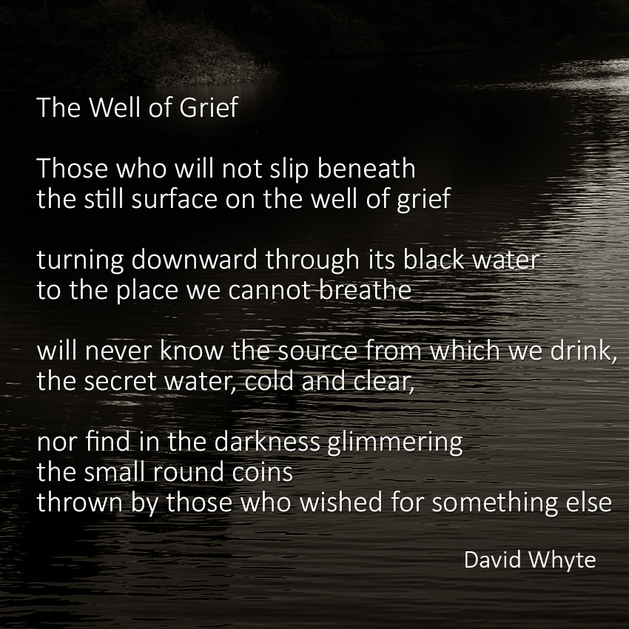

It started with the idea of trying to evoke a sense of what means to be suspended in a world of very cold water. What this meant for me as I grieve the death of my son and how with this new addiction I have found the space to search deeper into what it really means to live with such a loss.

I GRIEVE THEREFORE I SWIM ….
I have always enjoyed a good swim whether in a pool or open water. But since Josh died I have taken to swimming with added enthusiasm – especially wild swimming. In fact swimming has become an essential part of the way I grieve for Josh. It connects me to him in ways that I have found to be both surprising and rewarding..
There is no other activity that I have found that is so meditative, so in the moment and so far away from reality or the timescale of everyday living. I love being on my own underwater, feeling the water gliding past me as I pull on each stroke, breathing on every forth and finding the rhythm that will take me to the ‘zone’. When I get into the rhythm of my swim, stroke after stroke, breath after breath, I can achieve a kind of serenity – there’s a peace here, where alone in this watery world I feel I am as close to death as I dare go and as close to Josh as I’ll ever be while I still do breathe

But within just a few weeks of preparatory filming, the film and the project has now become a bit more of a challenge – I am going to attempt an ICE Mile. That means swimming for a mile in water temperatures below 5°C – without a wetsuit. I have swum this distance and more in a suit and in temperatures as low as 10°C but an Ice Mile is a totally different ball game. And it’s going to need a serious amount of training to get there. But for me it’s this very process of getting to the level of fitness required to achieve this feat that is more interesting and in the end more valuable than the target itself. Grief after all is not a one off event.
WHEN
An Ice Mile is a fully accredited event governed under the rules of the International Ice Swimming Association and with water temperatures in this country rarely dropping below 10°C for most of the year, my attempt is planned for early in January 2019. What I’m hoping to do is to train regularly through the seasons as the temperature rises and then drops and then by taking in some of the more iconic wild swimming locations across the UK including Clevedon tidal pool, Crummock water, the Rivers Dart and Waveney and any one of hundreds of lochans in Scotland, I hope to provide a sense of how varied and beautiful open water swimming can be.
GET INVOLVED
Do you have a story to tell how wild or cold water swimming has helped you? Can you articulate why you love it. What is it about immersing yourself in very cold water that thrills you? Are you looking to find your way out of depression or like me does it help you with your grief? If any of the above applies we’d love to hear from you? We are looking for around four or five stories to help illustrate the extraordinary wonders of wild swimming and those who do it.
Your involvement in the project will mean a commitment of 2 to 3 filming days at different times throughout the year. We would need to visit you at to your home and your swimming locations and you must be prepared to talk on camera about any difficulties, mental issues, or traumas that have led you to seek comfort and sustenance from swimming in the wild.
If this is you please write to me: jimmy@beyondgoodbye.co.uk with just a short paragraph explaining how and why you would like to take part.
We have already shot a number of scenes but filming will continue throughout 2018 and the early part of 2019.
Come and see the work in progress at the Marshall Rooms in Stroud as part of the Stroud Film Festival.

